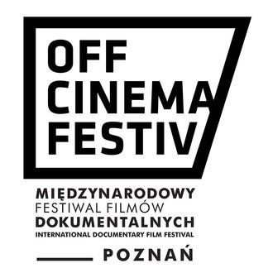
26. MFFD OFF CINEMA 18-23.10.2022, POZNAŃ

GUEST ACCREDITATION
FORM
Surname:
Name:
Phone number:
E-mail:
Country:
Special diet (e.g. vege,

vegan, gf, etc.):
Date of arrival:
Date of departure:
Number of nights:
Please select the days on which you will be participating in the Festival:

18 | 19 | 20 | 21 | 22 | 23

Guest contact:
Dawid Skórzybut
offcinema@ckzamek.pl
+48 514 878 959

